***Example 1:*** The distribution of Iowa Test of Basic Skills (ITBS) vocabulary scores for 7th-grade students in Gary, Indiana, is close to Normal. Suppose the distribution is N(6.84, 1.55).

1. Sketch the Normal density curve for this distribution.

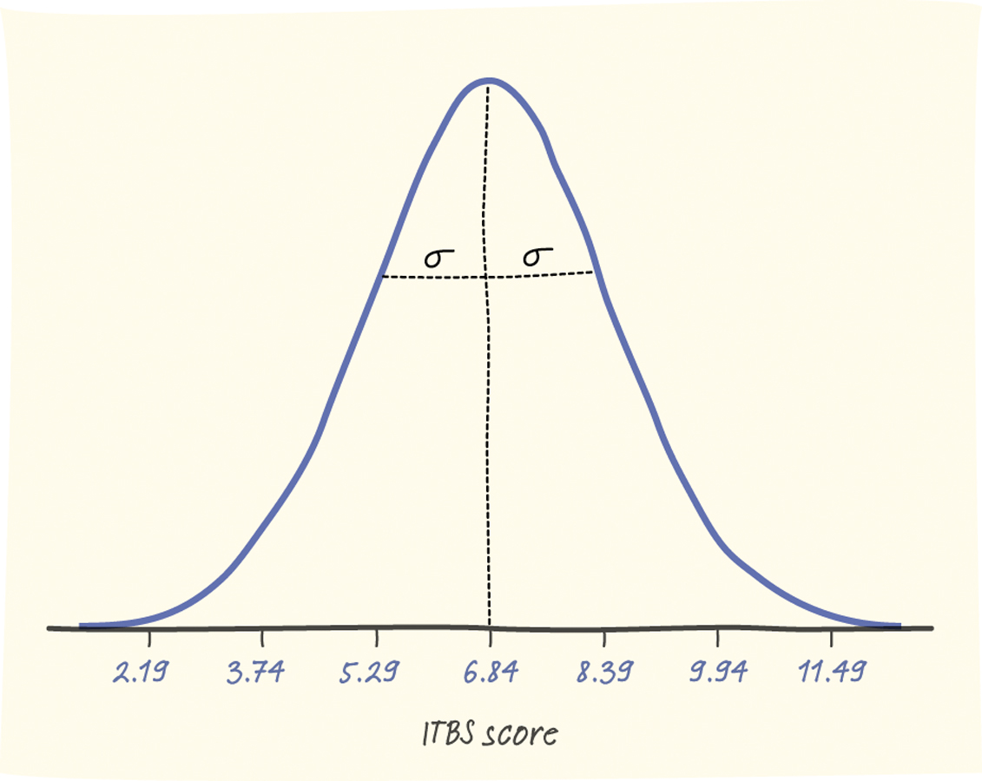

1. What percent of ITBS vocabulary scores are less than 3.74?

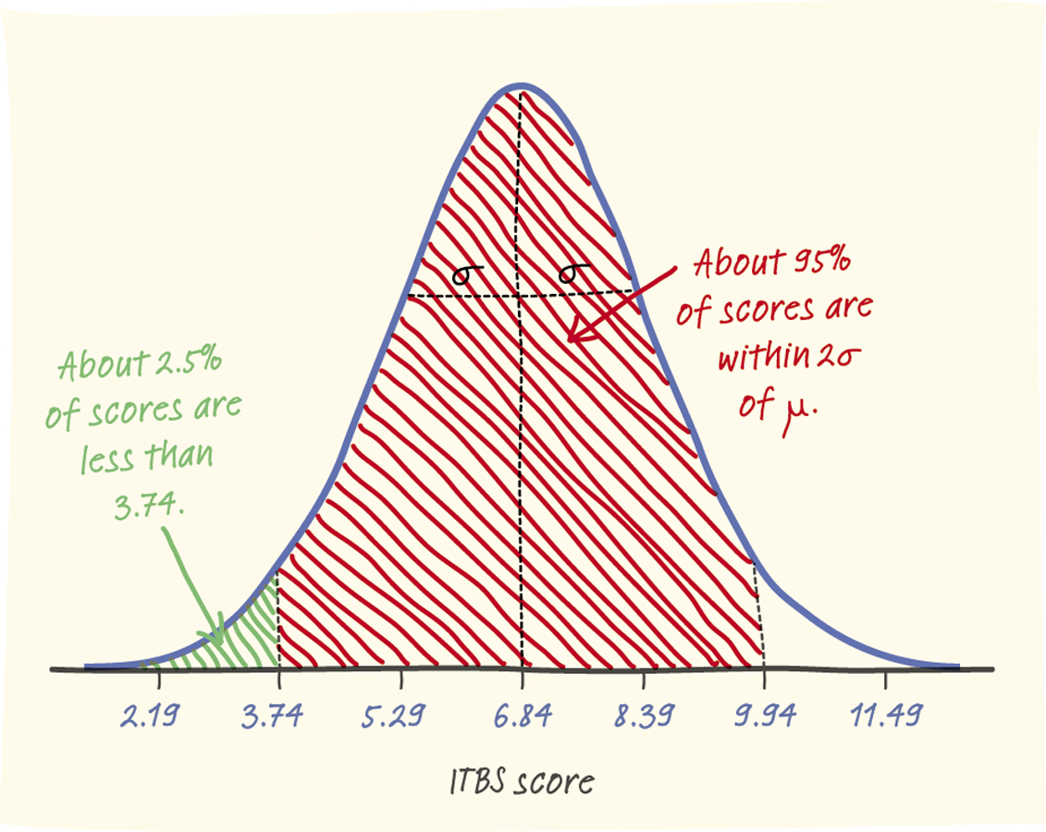

1. What percent of the scores are between 5.29 and 9.94?

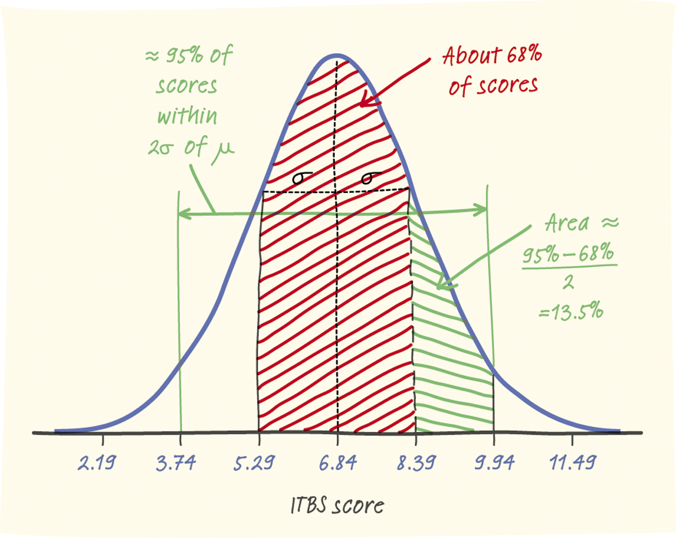

***Example 2:***

John: = 0.9434

Alysha: = 1.3276